**Virtual Packaging Inc.**

**Functional Specification Doc.**

June 2018

Developed by:



Contents

1. VERSION CONTROL 5

2. OVERVIEW 5

3. Work Flow 6

4. LOGIN 7

4.1 Asterisk Fields 7

4.2 Username 7

4.3 Password 8

4.5 Log-in Button 8

5. Forgot Password 8

5.1 Description 8

5.2 Asterisk Fields 8

5.3 User Email 8

5.4 Request Button 9

5.5 Cancel Button 9

6. Profile 9

6.1 View Profile 9

6.2 Edit Profile 10

6.3 Save Button 10

7. Change Password 10

7.1 Asterisk Fields 10

7.2 New Password 10

7.3 Confirm Password 11

7.4 Save Button 11

8. Customers 11

8.1 View Customer’s list 11

8.2 Add Customer 12

8.2.1 Add Button 12

*8.2.2* Close Button 13

*8.3* Asterisk Fields 13

8.4 Search Customer 13

8.5 Filter Customer 13

8.6 Actions in Customer Grid 13

8.7 Pagination 15

8.8 Customer Detail’s Page 15

8.8.1 Quotes tab 15

8.8.2 Jobs Tab 17

8.8.3 Contacts Tab 19

8.9 Customer Actions 22

8.10 Customer Notes 23

9. Leads 24

9.1 View Lead’s List 24

9.2 Add Lead 25

9.2.1 Add Button 25

9.2.2 Close Button 26

9.3 Asterisk Fields 26

9.4 Search Lead 26

9.5 Filter Lead 26

9.6 Actions in Lead Grid 26

9.7 Pagination 28

9.8 Lead’s Details Page 28

10. Users 28

10.1 View User’s List 28

10.2 Add User 29

10.2.1 Add Button 29

10.2.2 Close Button 30

10.4 Search User 31

10.5 Actions in User Grid 31

10.6 Pagination 32

11. Settings 33

11.1 View the drop-down list 33

11.1.1 Product Types: 33

11.1.2 Product Sub-option: 37

12. Product Sub-Product 39

12.1 View Sub-Product’s List 39

12.2 Add Sub-Product 40

12.3 Add Sub-Option 41

12.4 Edit Sub-Product 42

13. Product Material 43

13.1 View Material’s List 43

13.2 Add Material 43

13.3 Edit Material 44

14. Quotes 45

14.1 View the Quotes drop-down 45

14.2 Add New Quote 45

14.2.1 Basic Information 45

14.2.2 Products 47

14.2.3 Terms & Conditions 49

14.2.4 Save Button 49

14.2.5 Save and Approve Button 49

14.3 View the list of Existing Quotes 50

14.4 Add Quote 51

14.5 Search Quotes 51

14.6 Filter Product 51

14.7 Actions on Grid 51

14.8 Pagination 51

14.9 Quotes Details Page 52

14.10 Quotes Notes 52

15. Jobs 53

15.1 View the Job’s calendar 53

15.2 Notes 58

15.3 Search Jobs 59

15.4 Filter Jobs 59

15.5 Actions on Grid 59

15.6 Pagination 59

15.7 Jobs Details Page 59

15.7.1 Basic Information page 60

15.7.2 Product Information 60

15.7.3 Job Information 60

15.7.4 Shipping Information 61

15.7.5 Save Button 62

# VERSION CONTROL

|  |  |  |  |
| --- | --- | --- | --- |
| **Date** | **Version** | **Author** | **Notes** |
| 07/18/2018 | V1.0 | Bhrugisha | After discovery sessions and UI demo 1 feedback |
| 07/27/2018 | V1.1 | Bhrugisha | Changes and updates after UI Demo 2 |

# 

# OVERVIEW

The document details all the functionalities that are incorporated in the VPI application.

# 

# Work Flow

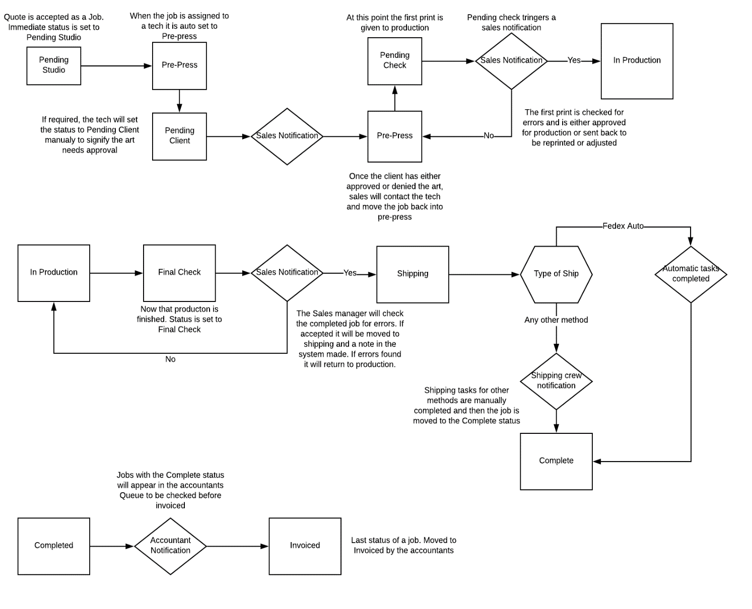**Normal workflow:**

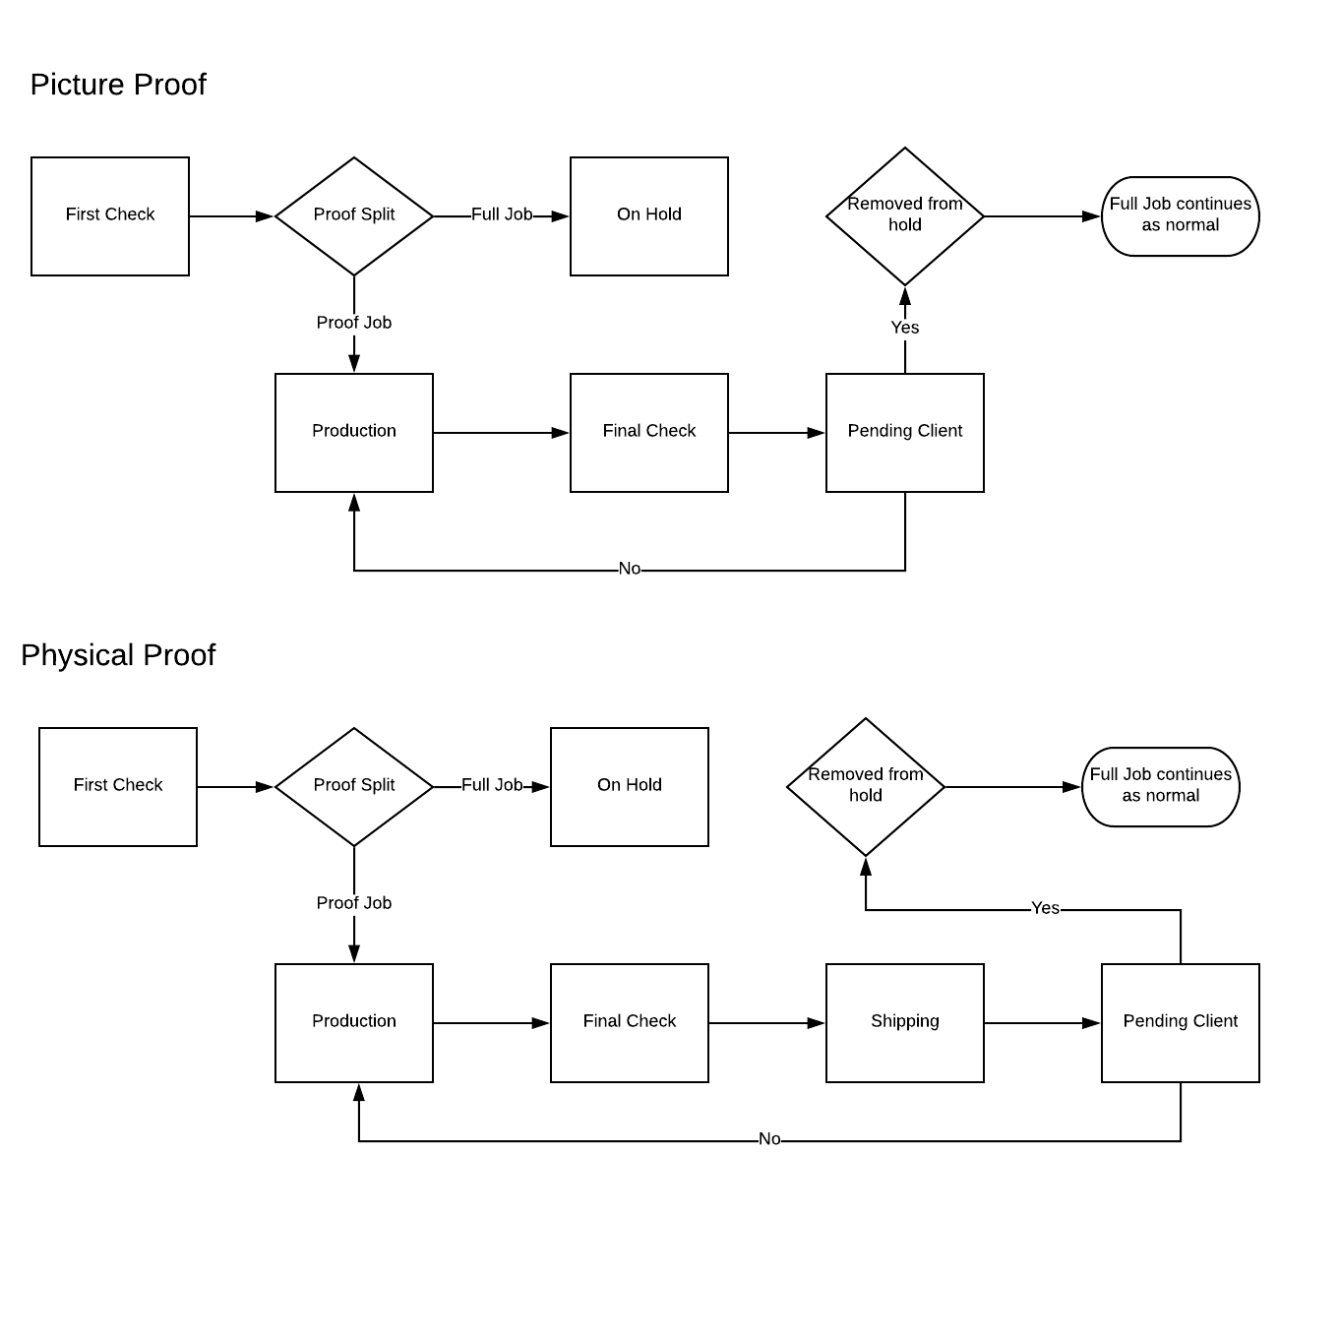If Picture Proof and/or Physical Proof is required for the quote, then following if additional process to normal flow.

# LOGIN

### Asterisk Fields

* To log into the VPI system, the system should not be able to give user ability to continue unless the below fields are filled –
* Username
* Password

### Username

* User should be able to provide valid username i.e. an alpha-numeric text to log into the system.
* System should be able to validate the username input to make sure an active user record exists in database with the username provided.

### Password

* User should be able to provide valid password of length 4-16 characters.
* System should be able to validate the password input to make sure an active user record exists in database with the password provided.
  1. **Remember Me**
* User should be able to check the “Remember me” checkbox for the system to remember the login credentials.
* System should be able to cache this information for next time login.

### Log-in Button

* System should be able to validate username and password (or login credentials) user provided when user hit “Login” button.
* With successful authentication of user, the system should be able to give access to that user.
* If authentication fails, the system should be able to display a message in red ‘Please enter correct username and password to login.’

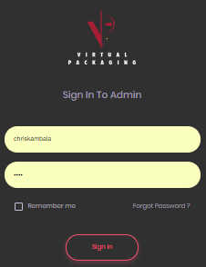

# Forgot Password

### Description

* User should be able to click on forgot password link in login page to recover the forgotten password. The system should be able to redirect to forgot password page.

### Asterisk Fields

* System should not be able to give user ability to continue unless the below fields are filled –
* User Email

### User Email

* User should be able to provide valid email id to recover their password to access the system.

### Request Button

* System should be able to validate email ID provided when user clicks on Request button in forgot password page
* With successful validation of user, the system should be able to send login-link on their provided email id.
* User should be able to click on the provided link to access the system and then update their password.
* If email id does not exist in the system, then system should be able to display a message in red ‘Invalid: Your email address does not exist.’

### Cancel Button

* User should be able to click on Cancel button to go back to login page from forgot password page.

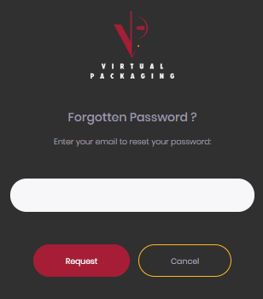

# Profile

### View Profile

* The user should be able to view following fields:
* First Name
* Last Name
* Email
* Phone
* Profile Picture
* Role

### Edit Profile

* User should be able to edit following information:
* First Name (text-box)
* Last Name (text-box)
* Phone (Text-box)
* Profile Picture (Change profile picture) (Browse)
* User should not be able to edit the read only fields – Email and Role

### Save Button

* User should be able to click on Save button to save the updates made to their profile. The changes should be updated in database and the page should be refreshed in front-end and changes should be reflected in whole system.

# Change Password

### Asterisk Fields

* To Change Password of an existing VPI account, the system should not be able to give user ability to continue unless the below fields are filled –
* New Password
* Confirm Password

### New Password

* User should be able to provide valid password of length 4-16 characters. System should be able to validate the password – not same as previously used password and should be of length 4-16 characters.
* If the password doesn’t meet the criteria of the length, then show warning message “Please enter password of 4-16 characters.”
* If the password entered is same as previously used passwords then show warning message “Please use a different password, this password was used before.”

### Confirm Password

* User should be able to provide same password as he/she provided in New password field.
* If it matches then proceed with changing password, if not then show the warning message “The passwords do not match.”

### Save Button

* User should be able to click on Save button to update the new password for the logged in account.
* If update was successful, then display notification ‘Password Changed’ if it fails the display notification ‘Fail: Change Password’.

# Companies

### View Companies list

* User should be able to click on Company’s Tab from the menu panel to open the Company’s list page.
* User should be able to view following columns in the Company’s grid-
* Name
* Email
* Phone
* Address
* Assigned to
* Actions: Add Quote, Edit and Delete
* The bubble besides the name of the Company indicates Number of Active Jobs in Blue. If the Company doesn’t have any active job, then do not show the bubble.
* User should be able to click on Company Name to open Company details page
* The Company grid should have pagination, giving user ability to select the number of entries to display from the drop-down.

### Add Company

* ‘Add Company’ button should be in top-right section of the Company’s list grid.
* User should be able to click on add Company button to open the add Company pop-up with following fields –
* Company Name (Text-box)
* Primary Email (Text-box)
* Primary Phone (Text-box) (Numeric)
* Assign to (Drop-down)

**Mailing Address**

* Address 1 (Text-box)
* Address 2 (Text-box)
* City (Text-box)
* State (Drop-down)
* Display all the states of USA
* Zip-Code (Text-box) (Numeric only)

**Billing Address**

* Is same as Mailing Address (Check box)
* Address 1 (Text-box)
* Address 2 (Text-box)
* City (Text-box)
* State (Drop-down)
* Display all the states of USA
* Zip-Code (Text-box) (Numeric only)

### Add Button

* User should be able to click on Add button to save the Company’s information. The system should validate the fields and display following notifications-
* If all required and valid information is provided, the system should be able to show notification, ‘Company Added’
* If some information is missing, for example first name, then system should be able to show notification, ‘Please enter Company Name’. Syntax: ‘Please Enter ‘missing mandatory field’’ and highlight the ‘Company Name’ field in red.
* If invalid data entered in field, for example, characters in Zip code, then system should be able to show notification, ‘Please enter valid Zip Code and highlight the ‘Zip’ field in red.
* **Note:** If the record is inserted via Add Company pop-up in Company Tab, the table should keep the **IsProspect** field unchecked while adding Company record in the database.

### Close Button

* User should be able to close the Add Company pop-up by clicking on close button. The system should be able to re-direct user to last active page.

### Asterisk Fields

* For Adding New Company to VPI, the system should not give user ability to continue unless the below fields are filled –
* Company Name
* Primary Email
* Primary Phone
* Assigned To
* Mailing Address: Address 1, Address 2, City, State and Zip-code

### Search Company

* User should be able to search the list of Companies by using Company Name and Email-id
* User should be able to search the record using partial/full text.



### Filter Company

* User should be able to click on  icon to open the filter panel in the Companys tab.
* User should be able to filter the Company list by Sales Representatives. User should be able to multi-select the sales representatives with help of check-boxes.

### Actions in Company Grid

* User should be able to click on Action icon to open the action drop-down with Add Quote, Edit and Delete items.
* Each Company should be able to have individual actions drop-down, user should be able to performs respective actions by selecting respective icons on the selected Company.

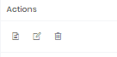

#### **Add New Quote**

* User should be able to add new quote for a specific Company by clicking on  add quote icon from selected Company’s actions list.
* System should be able to open add new quote page for that Company.
* System should not be able to display the company field in add quote page when directed from Company page, system should be able to display the Company’s company name by default.
* **Refer 12.2** for further details.

#### **Edit**

* User should be able to select  Edit icon from actions, to edit the existing Company.
* Edit Company pop-up should have all the fields editable and same as the Add Company pop-up along with same validations.
* User should be able to edit the information and click on Save changes button to save the changes to database
* User should be able to click on close button to close the edit Company pop-up, without saving any updates.
* Any updates done to Company information should be added to selected Company’s activities.

#### **Delete**

* User should be able to select  icon from the actions, to delete the existing selected Company.
* System should be able to ask the user for confirmation with confirmation pop-up before deleting the selected Company.
* If user clicks on Yes, the system should be able to delete the existing Company and if no, then system should make no changes to the Company’s account.

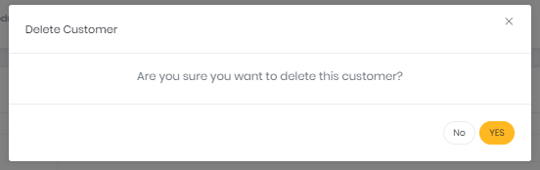

### Pagination

* User should be able to see the list of Companys with the following paginations:
* User should be able to select the number from drop-down which represents the number of records to be shown in the list, i.e. if user selects 10, the list should display 10 records, if user selects 100, the list should display 100 records from the system.

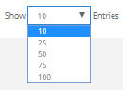

* System should display the information of the range of records display out of the total.



* User should be able to navigate to available page numbers, next page or the last/first page of the list of records.



### Company Detail’s Page

* should be able to view the following Company information by clicking on Company name in the Company’s grid: Company name, Primary Email, Primary Phone, Mailing Address, Billing Address, Quotes tab User, Jobs Tab, Contacts Tab, Notes icon,Company Actions: Edit and Send Email

### Quotes tab

* User should be able to view the list of quotes for the selected Company having following columns in the grid:
* Quote Number
* Name
* Date
* Created By
* Total Status
* Actions: Approve, Create Duplicate and Delete
* User should be able to click on Quote Number to open Quote details page. The quote details page should be by default in an edit mode. User should be able to edit the information can click on save button to save the updates.

1. **Approve Quote:**

* User should be able to click on  icon to approve the quote and convert it into a job. When user clicks on the approve icon, the system should be able to open the job details page where user should be able to edit and update more information about the job.
* The information from the quotes details should get pre-populated in the fields of job details page for the selected quote.
* **Note:** Once the quote gets approved, that quote should be removed from quotes table and should be reflected as job card in job’s board. (add it to jobs table).

1. **Create Duplicate:**

* User should be able to click on Create duplicate icon to create copy of the selected quote.
* System should be able to open the add quote page pre-populated with original quote details in edit mode.
* User should be able to make changes and save the quote with new quote id.
* User should be able to Approve and Save the quote by clicking on approve and save button.
* **Note:** Duplicate quote should have different quote id then original quote.

1. **Delete Quotes:**

* User should be able to select  icon from the actions, to delete the existing selected quote.
* System should be able to ask the user for confirmation with confirmation pop-up before deleting the selected quote.
* If user clicks on Yes, the system should delete the existing quote and if no, then system should make no changes to the quote.

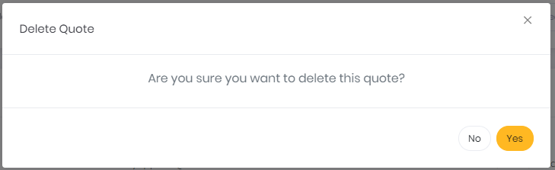

### Jobs Tab

* User should be able to view the list of jobs for the selected Company and the grid should be able to have following columns in the grid: Job Number, Name, Contact, Total, Due Date By, No. of Shipments, Status, Actions: Add Covering Associate and Delete
* User should be able to click on Job Number to open Job details page. The job details page should be by default in an edit mode. User should be able to edit the information can click on save button to save the updates.

1. **Change Status:**

* System should be able to display the status drop-down when the user clicks on the existing status value in status column.
* User should be able to click on the status from the status column and the system should be able to open a pop-up with job status drop-down and comments text-area to add comments for this change.
* The comments are not mandatory.

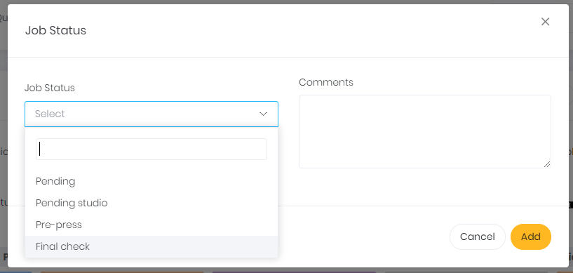

* System should be able to change status colour and update in it the jobs page.
* Following are the job status with their respective colours:



**Notes:**

* While changing status to shipping in the pop-up, instead of ‘Add’ button, system should be able to show ‘Create Label’ button.
* as As soon user clicks on create label, the system should be able to validate whether shipping address with shipping method is selected or not, if yes then continue with label creation.

If no, then redirect user to that job’s shipping tab.

* Once user clicks on create label button, create the shipping label for that job and save it.

1. **Add Covering Associate**

* User should be able to select Add covering associate for the selected job by selecting Add Covering Associate option from the actions column.
* System should be able to open add covering associate pop-up, with following fields:
* Role (Drop-down) (Mandatory)
* Name (Drop-down) (Worker name) (Mandatory)
  + User should be able to click on add button to assign selected covering associate for the selected job, only after validating the fields.
* System should be able to send to both email notification the workers with content format ‘Worker B is added as covering associate for Worker A for Job Id J12345 on ‘timestamp’ by ‘Logged In user’’.
* If some information is missing, for example Role, then system should be able to show notification, ‘Please Select Role’. Syntax: ‘Please Enter ‘missing mandatory field’’ and highlight the ‘Role’ field in red.

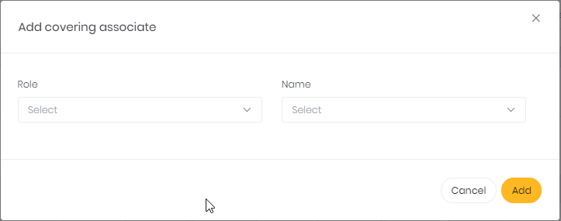

1. **Delete Job:**

* User should be able to select  icon from the actions, to delete the existing selected job.
* System should be able to ask the user for confirmation with confirmation pop-up before deleting the selected job.
* If user clicks on Yes, the system should be able to delete the existing job and if no, then system should make no changes to the job.

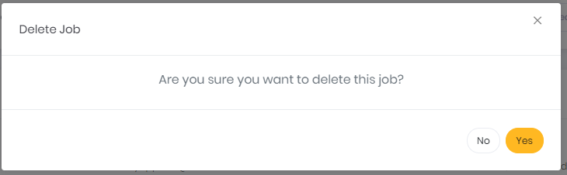

### Contacts Tab

* User should be able to view the list of contacts for the selected Company having following columns in the grid: Name, Phone, Email, Address Actions: Edit and Delete

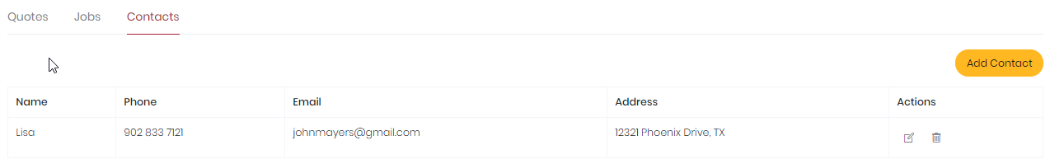

1. **Add Contact**:

* User should be able to add new contact for selected Company by clicking on the  icon in the top-right section of the contact’s tab.
* Add contact pop-up should have following fields:
* Name (Text-box)
* Phone (Text-box) (Format: (123) 456-7890)
* Email (Text-box)
* Address (Text-box)

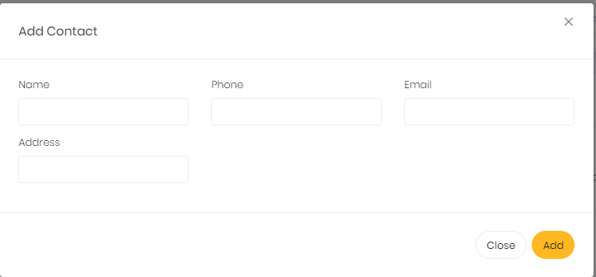

1. **Add Button**

* User should be able to click on Add button to save the contact information. The system should be able to validate the fields and show following notifications:
* If all required and valid information is provided, the system should be able to show notification, ‘Contact Added’
* if some information is missing, for example Name, then system should be able to show notification, ‘Please enter Contact Name’. Syntax: ‘Please Enter ‘missing mandatory field’’ and highlight the ‘Contact Name’ field in red.
* If invalid data entered in field, for example, characters in Phone, then system should be able to show notification, ‘Please enter valid Phone and highlight the ‘Phone’ field in red.

1. **Close Button**

* User should be able to close the Add Contact pop-up by clicking on close button. The system should be able to return user to last active page.

1. **Edit Contact:**

* User should be able to edit the contact details for selected Company by clicking on  icon from the actions.
* User should be able to edit the information and click on Save changes button to save the changes to database
* User should be able to click on close button to close the edit contact pop-up, without saving any updates made.

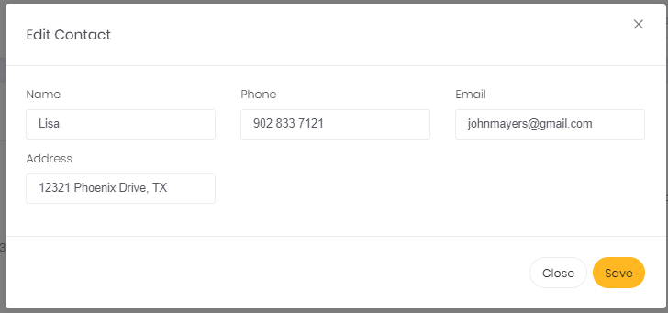

1. **Delete Job:**

* User should be able to select  icon from the actions, to delete the existing selected contact.
* System should be able to ask the user for confirmation with confirmation pop-up before deleting the selected contact.
* If user clicks on Yes, the system should be able to delete the existing contact and if no, then system should be able to make no changes to the contact.

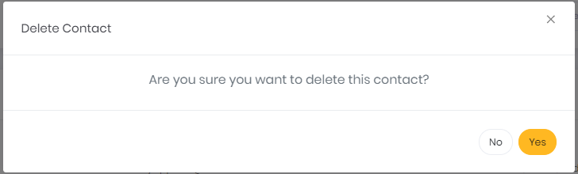

### Company Actions

* User should be able to perform actions – Edit and Send Email on the selected Company by clicking on  icon and selecting from the drop-down.

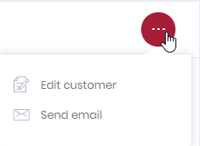

#### **Edit Company**

* User should be able to edit the Company details for selected Company by selecting edit Company from the actions drop-down.
* The fields of the edit Company pop-up should be same as the fields of add Company pop-up, but pre-populated with selected Company details.
* User should be able to edit the information and click on Save changes button to save the changes to database
* User should be able to click on close button to close the edit Company pop-up, without saving any updates made.

#### **Send Email**

* User should be able to select send email option from the actions drop-down and the system should be able to open email editor as the pop-up.
* User should be able to fill-in the details – From, To, Subject and Email Body – and the email to the Company.
* By default, system should be able to have Logged in workers email id in ‘From’ field and selected Company’s email id in ‘To’ field. User should be able to edit these fields.
* User should be able to click on ‘Send’ button to send the email to the Company, by validating all fields.
* User should be able to click on ‘Close’ button to close the email editor and go back to last active page.

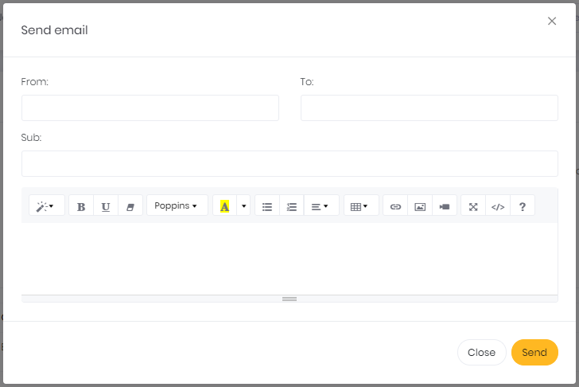

### Company Notes

* User should be able to write notes for selected Company by clicking on the  icon which is floating in the Company’s details page.
* When user clicks on notes icon, a panel slides open from the right. The panel has two tabs – Notes and Activities.
* User should be able to view all the notes present for the selected Company with timestamp and which worker entered the notes.
* User should be able to enter the notes in the text area in the bottom section of the panel and click enter or on  icon to submit the note.
* The  icon highlights in blue then there are few notes pending to be read by the user. The small bubble should contain the number of pending notes for the selected Company.
* System should be able to add all the activities/actions performed on the selected Company in the Activities tab with timestamp.
* System should be able to record: updates made to Company details, email sent, quotes added, quotes edited, quotes deleted, quote converted into jobs, job updates, job delete, contact added, contact update, contact delete.
* System should be able to slide- close the panel to the right when user clicks anywhere outside the panel.

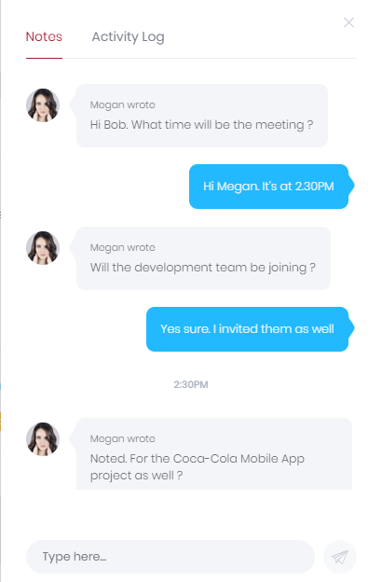 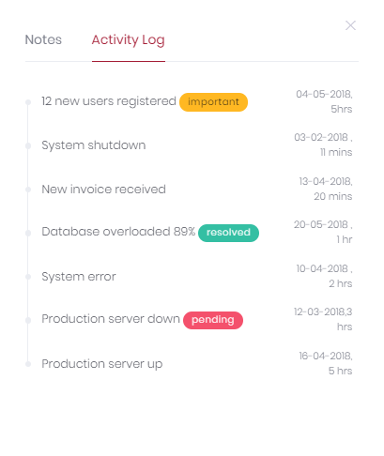

# Leads

### View Lead’s List

* User should be able to click on Lead’s Tab from the menu panel to open the Lead’s list page.
* User should be able to view following columns in the Lead’s grid-
* Name
* Email
* Phone
* Address
* Assigned to
* Actions: Add Quote, Edit and Delete
* The bubble besides the name of the Lead indicates Number of Active Quotes in Red. If the Lead doesn’t have either Active quotes, then do not show the bubble.
* User should be able to click on Lead Name to open Lead details page
* The Lead grid should be able to have pagination, giving user ability to select the number of entries to display from the drop-down.

### Add Lead

* ‘Add Lead’ button should be in top-right section of the Lead’s list grid.
* User should be able to click on add Lead button to open the add Lead pop-up with following fields –
* Lead Name (Text-box)
* Primary Email (Text-box)
* Primary Phone (Text-box) (Format: (123) 456-7890)
* Assign to (Drop-down)

**Mailing Address**

* Address 1 (Text-box)
* Address 2 (Text-box)
* City (Text-box)
* State (Drop-down)
* Display all the states of USA
* Zip-Code (Text-box) (Numeric only)

**Billing Address**

* Is same as Mailing Address (Check box)
* Address 1 (Text-box)
* Address 2 (Text-box)
* City (Text-box)
* State (Drop-down)
* Display all the states of USA
* Zip-Code (Text-box) (Numeric only)

### Add Button

* User should be able to click on Add button to save the Lead’s information. The system should be able to validate the fields and show following notifications:
* If all required and valid information is provided, the system should be able to show notification, ‘Lead Added’
* If some information is missing, for example first name, then system should be able to show notification, ‘Please enter Lead Name’. Syntax: ‘Please Enter ‘missing mandatory field’’ and highlight the ‘Lead Name’ field in red.
* If invalid data entered in field, for example, characters in Zip code, then system should be able to show notification, ‘Please enter valid Zip Code and highlight the ‘Zip’ field in red.
* Note: If the record is inserted via Add Lead pop-up in Lead Tab, the system should be able to **Check** the IsProspect check-box while inserting the leads record in the database.

### Close Button

* User should be able to close the Add Lead pop-up by clicking on close button. The system should be able to re-direct user to last active page.

### Asterisk Fields

* For Adding New Lead to VPI, the system should not give user ability to continue unless the below fields are filled –
* Lead Name
* Primary Email
* Primary Phone
* Assigned To
* Mailing Address: Address 1, Address 2, City, State and Zip-code

### Search Lead

* + User should be able to search the list of Leads by using Leads Name and Email-id
* User should be able to search the record using partial/full text.



### Filter Lead

* User should be able to click on  icon to open the filter panel in the Leads tab.
* User should be able to filter the Lead list by Sales Representatives. User should be able to multi-select the sales representatives with help of check-boxes.

### Actions in Lead Grid

* User should be able to click on Action icon to open the action drop-down with Add Quote, Edit and Delete items.
* Each Lead should be able to have individual actions drop-down, on selecting those, the user should be able to perform actions on the selected Lead.



#### **Add New Quote**

* User should be able to add new quote for a specific Lead by clicking on  add quote icon from that Lead’s actions.
* System should be able to open add new quote page for that Lead.
* **Refer 12.2** for further details.

#### **Edit**

* User should be able to select  Edit icon from actions, to edit the existing selected Lead.
* Edit Lead pop-up should be able to have all the fields editable and same as the Add Lead pop-up along with same validations.
* User should be able to edit the information and click on Save changes button to save the changes to database
* User should be able to click on close button to close the edit lead pop-up, without saving any updates made.
* Any updates done to Lead information should be added to selected Lead’s activities.

#### **Delete**

* User should be able to select  Delete icon from the actions, to delete the existing selected Lead.
* System should be able to ask the user for confirmation with confirmation pop-up before deleting the selected Lead.
* If user clicks on Yes, the system should be able to delete the existing lead and if no, then system should be able to make no changes to the Lead’s account.

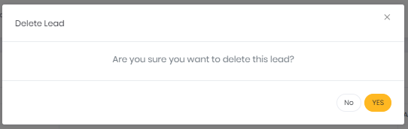

### Pagination

* User should be able to see the list of Leads with the following paginations:
* User should be able to select the number from drop-down which represents the number of records to be shown in the list, i.e. if user selects 10, the list should display 10 records, if user selects 100, the list should display 100 records from the system.



* System should be able to display the information of the range of records display out of the total.



* User should be able to navigate to available page numbers, next page or the last/first page of the list of records.



### Lead’s Details Page

* **Refer 7.8** section for more details.
* **Notes:**
* Leads details should not be able to have Jobs tabs.
* When quote for the selected lead is approved, the lead should be converted into the customer i.e. uncheck the IsProspect field for the selected lead which would convert them into customer in the table.

# Users

### View User’s List

* User should be able to click on User’s Tab from the profile menu list to open the User’s list page.
* User should be able to view following columns in the User’s grid-
* First Name
* Last Name
* Role
* Username
* Email
* Phone
* Actions: Reset Password, Edit and Delete
* The User grid should be able to have pagination, giving user ability to select the number of entries to display from the drop-down.

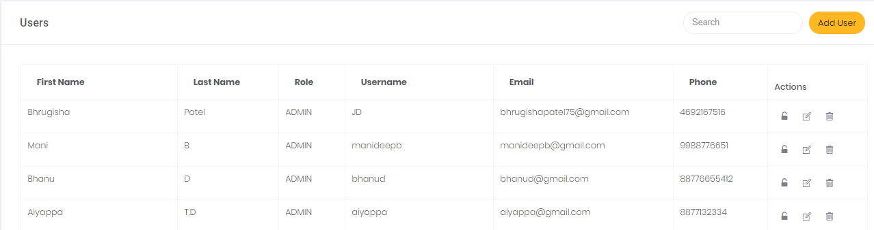

### Add User

* ‘Add User’ button should be in top-right section of the User’s list grid.
* User should be able to click on add User button to open the add User pop-up with following fields –
* First Name (Text-box)
* Last Name (Text-box)
* Role (Drop-down)
* Username (Text-box with Color code)
* Email (Text-box)
* Phone (Text-box)

**Note:** Admin should be able to give user a color code and that color code should be able to reflect in the responsible/user bubble throughout the application.

### Add Button

* User should be able to click on Add button to save the User’s information. The system should be able to validate the fields and show following notification:
* If all required and valid information is provided, the system should be able to show notification, ‘User Added’
* if some information is missing, for example first name, then system should be able to show notification, ‘Please enter User Name’. Syntax: ‘Please Enter ‘missing mandatory field’’ and highlight the ‘User Name’ field in red.
* If invalid data entered in field, for example, characters in Phone, then system should be able to show notification, ‘Please enter valid Phone and highlight the ‘Phone’ field in red.

### Close Button

* User should be able to close the Add User pop-up by clicking on close button. The system should be able to return user to last active page.

#### **Asterisk Fields**

* For Adding New User to VPI, the system should not be able to give user ability to continue unless the below fields are filled –
* First Name
* Last Name
* Role
* User Name
* Email
* Phone

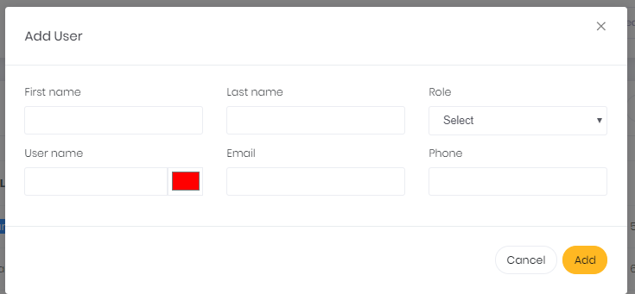

### Search User

* User should be able to search the list of Users by using username, first name, email-id and phone.
* User should be able to search the record using partial/full text.



### Actions in User Grid

* User should be able to click on Action icons - Reset Password, Edit and Delete, to open the action drop-down.
* Each User should be able to have individual actions drop-down, on selecting those, the user should be able to perform actions on the selected User.

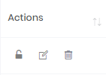

#### **Reset Password**

* User should be able to click on Reset password icon to reset the password for the selected user.
* System should be able to send email to the selected user with login hyperlink which will help the user to change password and log into the system.

#### **Edit**

* User should be able to select  Edit icon from actions, to edit the existing selected User.
* Edit User pop-up should be able to have all the fields editable and same as the Add User pop-up along with same validations.
* User should be able to edit the information and click on Save changes button to save the changes to database
* User should be able to click on close button to close the edit User pop-up, without saving any updates made.
* Any updates done to User information should be added to activities.

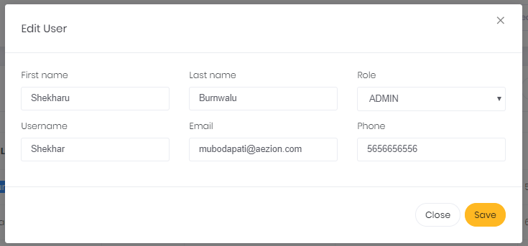

#### **Delete**

* User should be able to select  Delete icon from the actions, to delete the existing selected User.
* System should be able to ask the user for confirmation with confirmation pop-up before deleting the selected User.
* If user clicks on Yes, the system should be able to delete the existing user and if no, then system should be able to make no changes to the User’s account.

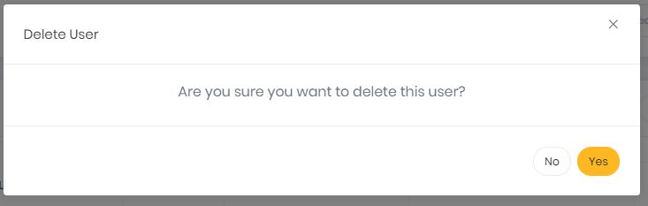

### Pagination

* User should be able to see the list of Users with the following paginations:
* User should be able to select the number from drop-down which represents the number of records to be shown in the list, i.e. if user selects 10, the list should display 10 records, if user selects 100, the list should display 100 records from the system.
* 
* System should be able to display the information of the range of records display out of the total.
* 
* User should be able to navigate to available page numbers, next page or the last/first page of the list of records.



# Settings

### View the drop-down list

* User should be able to click on Settings tab from the profile section and view the drop-down list of titles of the look-up tables.
* User should be able to select one of the titles from the settings list to view the grid of items it consists.
* Following is the list of look-up table:
* Product Types
* Product Sub-option
* Sources
* Product Types
* Print Types
* Job Status
* Finish Types
* Special Instruction

### Product Types:

1. **View Product’s List**

* User should be able to click on Product’s Tab from Settings Tab to open the Product’s list page.
* System should be able to list the product type – Box, Shrink, Bags, Label and Other in form of tabs.
* User should be able to view following columns in the products grid-
* Type
* Actions: Edit and Delete

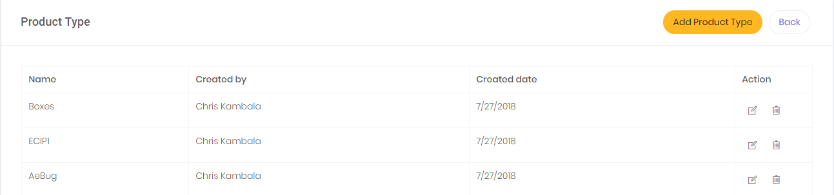

1. **Add Product**

* ‘Add Product’ button should be in top-right section of the Product’s list grid.
* User should be able to click on add Product button to open the add Product pop-up with following fields –
* Product Type (Text-box)

1. **Add Button**

* User should be able to click on Add button to save the Product’s information. The system should be able to validate the fields and show following notifications:
* If all required and valid information is provided, the system should be able to show notification, ‘Product Added’
* if some information is missing, for example name, then system should be able to show notification, ‘Please enter Product Name’. Syntax: ‘Please Enter ‘missing mandatory field’’ and highlight the ‘Product Name’ field in red.
* By default, in created by have the name of logged in user and in created date have today’s date.

1. **Cancel Button**

* User should be able to close the Add Product pop-up by clicking on cancel button. The system should be able to re-direct the user to last active page.

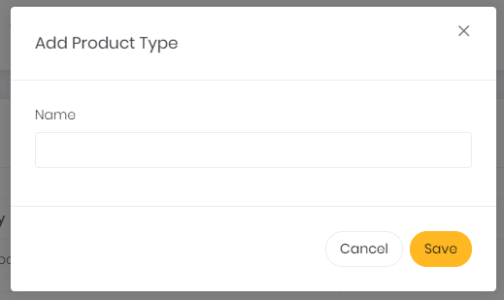

1. **Asterisk Field**

* For Adding New Product to VPI, system should not be able to give user ability to continue unless the below field is filled –
* Product type

1. **Actions in Product Grid**

* User should be able to click on Action icons, to open the action drop-down – Add Sub-Product, Edit and Delete
* Each Product should have individual actions drop-down, on selecting those, the user should be able to perform actions on the selected Product.

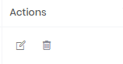

1. **Edit**

* User should be able to select  icon from actions, to edit the existing selected Product.
* Edit Product pop-up should have all the fields editable and same as the Add Product pop-up along with same validations.
* User should be able to edit the information and click on Save changes button to save the changes to database
* User should be able to click on close button to close the edit Product pop-up, without saving any updates made.
* Any updates done to Product information should be added to selected Product’s activities.

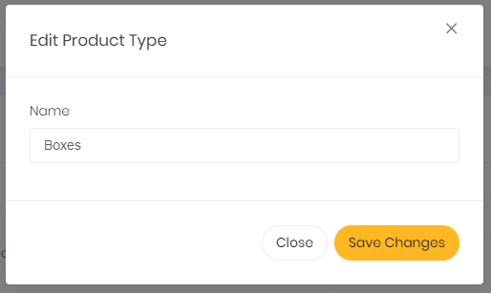

1. **Delete**

* User should be able to select  Delete icon from the actions, to delete the existing selected Product.
* System should be able to ask the user for confirmation with confirmation pop-up before deleting the selected Product.
* If user clicks on Yes, the system should be able to delete the existing product and if no, then system should make no changes to the Product’s account.

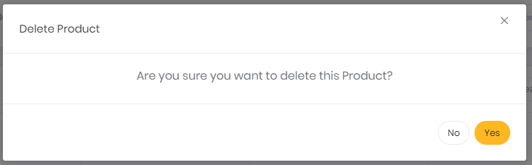

1. **Pagination**

* User should be able to see the list of Sub-Products with the following paginations
* User should be able to select the number from drop-down which represents the number of records to be shown in the list, i.e. if user selects 10, the list should display 10 records, if user selects 100, the list should be able to display 100 records from the system.



* System should be able to display the information of the range of records display out of the total.



* User should be able to navigate to available page numbers, next page or the last/first page of the list of records.



### Product Sub-option:

1. **View Sub-option’s list in form of tabs**

* User should be able to click on Sub-Option tab under settings tab in profile drop-down list.
* User should be able to view following columns in the sub-option grid-
* Sub-option Name
* Code
* Created By
* Create Date
* Actions: Edit and Delete

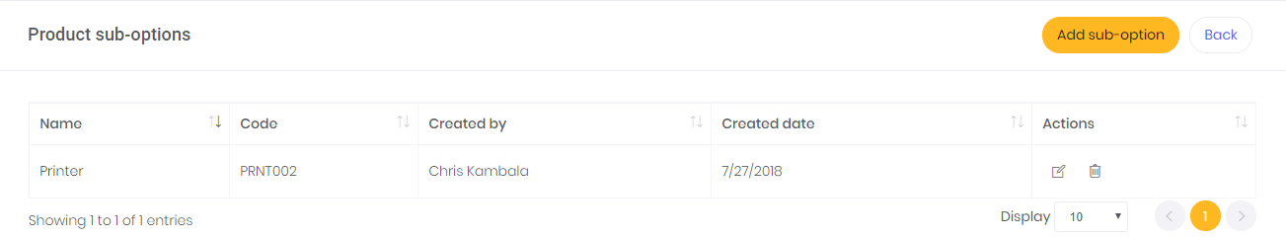

1. **Add Sub-Options**

* User should be able to add Sub-Option by clicking on the add sub-option button and system should be able to open Add sub-option pop-up.
* User should be able to view following fields:
* Name (Text-Box)
* Code (Text-box)

1. **Add Button**

* User should be able to click on Add button to save the sub-option information. The system should be able to validate the fields and show following notification:
* If all required and valid information is provided, the system should be able to show notification, ‘Sub-option Added’
* If some information is missing, for example name, then system should be able to show notification, ‘Please enter Name’. Syntax: ‘Please Enter ‘missing mandatory field’’ and highlight the ‘Name’ field in red.
* If invalid data entered in field, for example, characters in name, then system should be able to show notification, ‘Please enter valid Name and highlight the ‘Name’ field in red.

1. **Close Button**

* User should be able to close the Add sub-option pop-up by clicking on close button. The system should be able to return user to last active page.

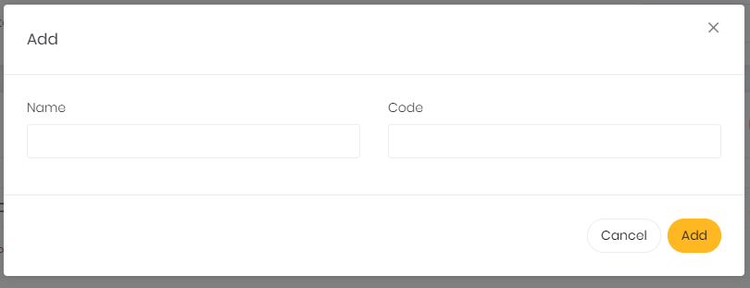

1. **Edit Sub-Option**

* User should be able to edit the Sub-Option details by clicking on edit button from the actions.
* User should be able to edit the details and click on Save changes button to save the changes to database
* User should be able to click on close button to close the edit program pop-up, without saving any updates made.

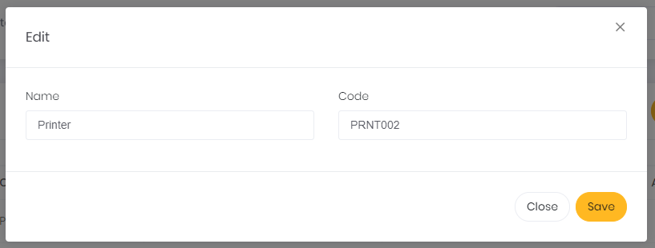

1. **Delete Sub-option**

* User should be able to select  Delete icon from the actions, to delete the existing selected Sub-Option.
* System should be able to ask the user for confirmation with confirmation pop-up before deleting the selected Sub-Option.
* If user clicks on Yes, the system should be able to delete the existing Sub-Option and if no, then system should make no changes to the record.

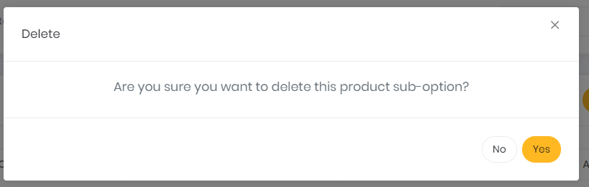

# Product Sub-Product

### View Sub-Product’s List

* User should be able to click on Sub-Product’s tab from profile drop-down list to open the list of Sub-Products available in the system.
* User should be able to view a static column of tabs with Product Type present in the system.
* When user clicks on a specific Product Type’s tab, the system should be able to display the Sub-Product grid for that specific Product Type. By default, the system should be able to display Sub-Product grid for first Product Type tab in the list.
* User should be able to view following columns in the Sub-Product grid-
* Name
* Description
* Labor Time
* Actions: Add Sub-Options, Edit and Delete
* The bubble besides the name of the sub-product type indicates Number of sub-options assigned to that specific sub-product type in Blue. If the customer doesn’t have any sub-option assigned, then do not show the bubble

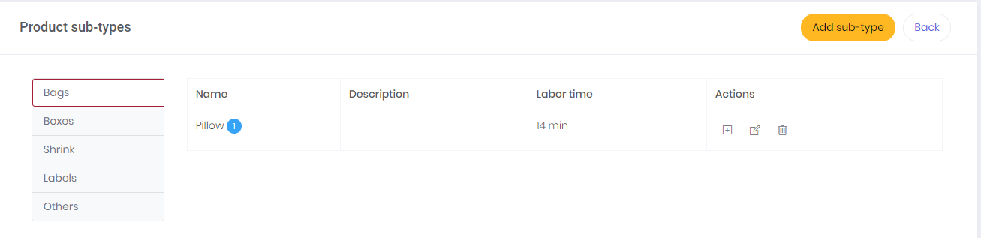

### Add Sub-Product

* User should be able to add new Sub-Product in the system by clicking on the add Sub-Product button and system should be able to open ‘add Sub-Product’ pop-up.
* User should be able to see following fields in the add program pop-up:
* Sub-Product Name (Text-box)
* Code (Text-box)
* Price (Text-box) (Format: $0.00)
* Unit (Drop-down- Per Square Feet and Per Cubic Feet)
* All the fields in the pop-up are mandatory.

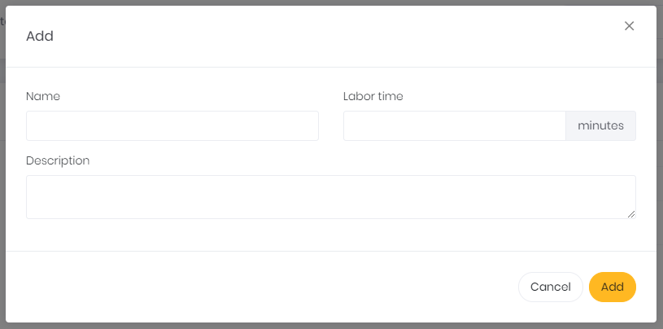

### Add Sub-Option

* User should be able to add sub-options for the selected sub-product type by clicking on add sub-option icon in the actions column.
* System should be able to display existing (left side) and available (right side) sub-options in the add sub-option pop-up.
* User should be able to click on ‘+’ icon besides the available sub-option to add them to the selected sub-product type.
* User should be able to search from list of all available sub-option types by providing Su-option name in the search bar.
* Once the sub-option is added to the selected sub-product do not show them in the list of available sub-options for the selected sub-product type.
* User should be able to delete/remove existing sub-option for the selected sub-product type by clicking on delete icon besides each existing sub-option.
* Once the sub-option is deleted/removed from the existing list, show them in the available list of sub-options for the selected sub-product type.
* User should be able to click on add to update all the changes made to the existing and available sub-options for selected sub-product type.
* User should be able to click on cancel to cancel the add sub-option pop-up and system should be able to redirect user to last active page.

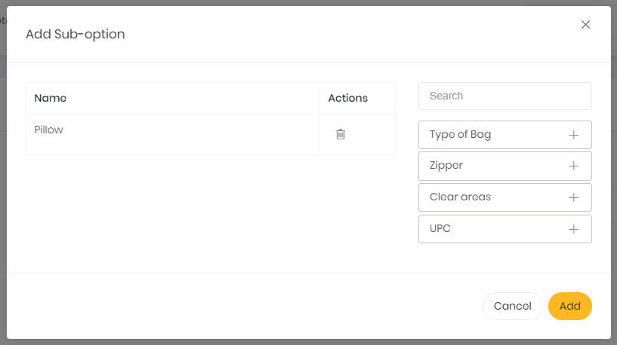

### Edit Sub-Product

* User should be able to edit the Sub-Product details by clicking on edit button from the actions.
* User should be able to edit the information and click on Save changes button to save the changes to database
* User should be able to click on close button to close the edit program pop-up, without saving any updates made.

#### **Delete**

* User should be able to select  Delete icon from the actions, to delete the existing selected Sub-Product.
* System should be able to ask the user for confirmation with confirmation pop-up before deleting the selected Sub-Product.
* If user clicks on Yes, the system should be able to delete the existing Sub-Product and if no, then system should be able to make no changes to the record.

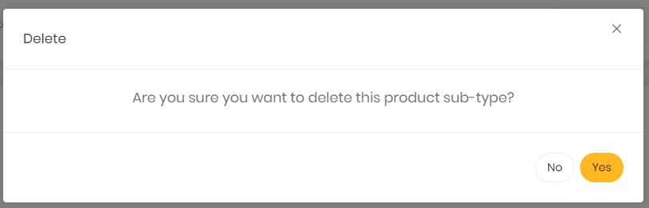

# Product Material

### View Material’s List

* User should be able to click on Product Material’s tab from profile drop-down list to open the list of materials available for the selected sub-option.
* User should be able to view a static column of tabs with sub-options present in the system.
* When user clicks on a specific sub-option tab, the system should be able to display the material grid for that specific sub-option. By default, the system should be able to display material grid for first sub-option tab in the list.
* User should be able to view following columns in the material grid-
* Name
* Code
* Price (with Unit)
* Actions: Edit and Delete

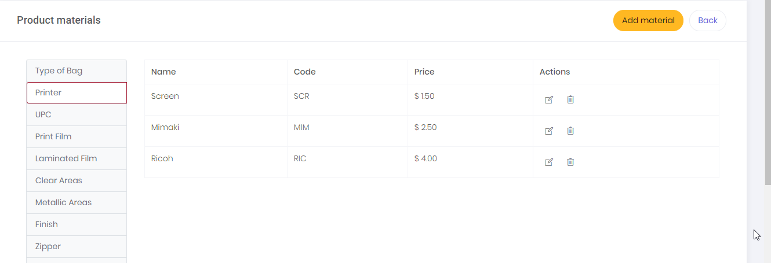

### Add Material

* User should be able to add new Material in the system by clicking on the add material button and system should be able to open ‘add material’ pop-up.
* User should be able to see following fields in the add program pop-up:
* Material Name (Text-box)
* Code (Text-box)
* Price (Text-box) (Format: $0.00)
* Unit (Drop-down- Per Square Feet and Per Cubic Feet)
* All the fields in the pop-up are mandatory.

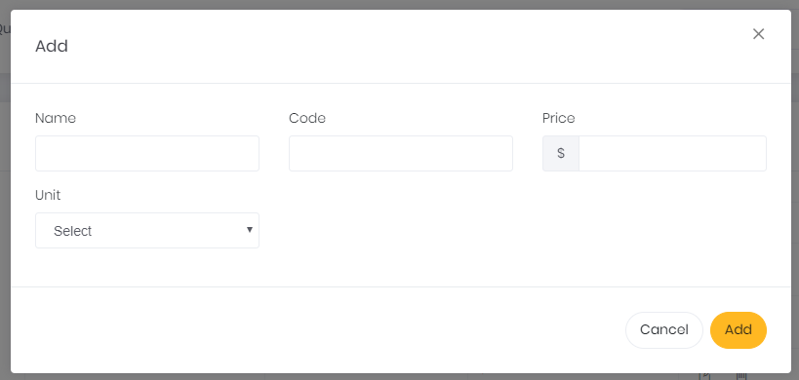

### Edit Material

* User should be able to edit the Material details by clicking on edit button from the actions.
* User should be able to edit the information and click on Save changes button to save the changes to database
* User should be able to click on close button to close the edit program pop-up, without saving any updates made.

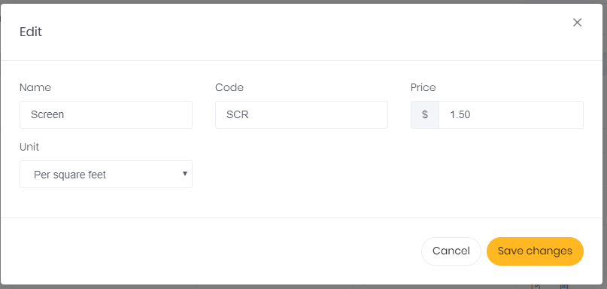

#### **Delete**

* User should be able to select  Delete icon from the actions, to delete the existing selected Material.
* System should be able to ask the user for confirmation with confirmation pop-up before deleting the selected material.
* If user clicks on Yes, the system should be able to delete the existing material and if no, then system should be able to make no changes to the record.

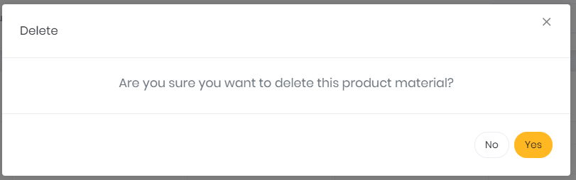

# Quotes

### View the Quotes drop-down

* User should be able to click on Quotes tab to view the options in the drop-down – Add New Quotes and View Quotes.
* User should be able to select one of the options and get re-directed to their respective pages.

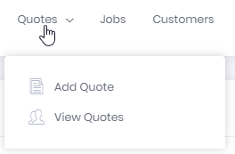

### Add New Quote

* User should be able to click on Quotes Tab and select Add Quotes to open Add quotes page.
* System should be able to auto-generate quote number and created date and display in top-right corner of the page.
* User should be able to view 3 tabs – Basic Information, Products and Terms & Conditions in add quotes pages.

### Basic Information

* User should be able to select the company from the drop-down, and system should be able to pre-populate all the information for the selected company.
* Company’s information should be read only.
* User should be able to view following fields in the Basic Information Tab:

**Company Information**

* Company (Drop-down)
* Contact
* Phone
* Email
* Address1
* Address1
* City
* State
* Zip
* Source

**Job Information**

* Project Name (Text-Box)
* Description (Text-area)
* Quoted By (Drop-down)
* Priority (Drop-down)
* Finish (Drop-down)
* Art Work Via (Drop-down – Desktop and Non-desktop) (If Non-Desktop selected display a text-box besides to fill in data)
* Printer 1 (Drop-down)
* Printer 2 (Drop-down) (shown printer excluding printer 1 option)
* Final Ship Date (Calendar)
* Delivery Date (Calendar)
* Flexible Ship (Check-box) (If this check-box is marked then only show Latest Shipping Date)
* Covering Associate (Drop-down)

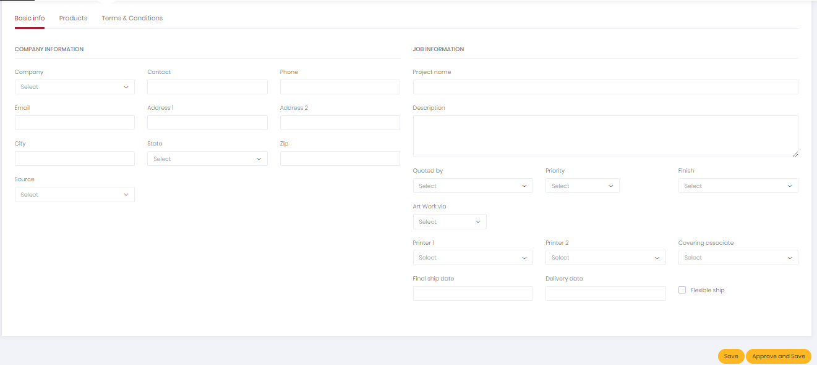

### Products

* User should be able to view static tabs for product type – Bags, Shrink, Labels, Boxes and Other in the products tab.
* Following are the required fields in each sub-product type’s grid:
* Sub-type (Drop-down) (Show options based on Product type selected)
* Quantity (Text-box)
* Description (Text-box) (auto-populate description of the selected product, it should be editable)
* Finish (Drop-down)
* Dimensions W/H (Inches) (Text-box) (numeric)
* Unit Price (field from look-up table)
* Surcharge (Drop-down) (Same Day, Standard, 24 Hours, 48 Hours)
* Total Price (Auto-calculated field for each product)
* User should be able to click on Add Product button to add one more row to the grid
* User should be able to view Sub-Total Amount per product type (sum of all sub-products for selected product type) of the quote in the bottom of the grid.
* System should be able to display a Tax check-box below the grid, If the tax check-box is checked then Tax field should by default calculate 8.25% of (sub-total), system should be able to display the amount in dollars. (Do not show %, just display actual dollars of tax).
* System should be able to calculate grand total including all the sub-totals from all the product type, taxes and discounts are added and display the grand total in bold.
* System should be able to display checkbox for discount after the tax checkbox and if user checks the checkbox then system should be able to display a drop-down besides the checkbox with discounts ranging from 5% to 25%.
* User should be able to select one option from the discount range.
* System should be able to display ‘Discounted amount’ field as label below discount check-box which should calculate discount in dollars based on Discount percentage selected by user.
* System should be able to calculate grand total ((sub-total +taxes) – discount) and display the amount in bold below the discounted amount.
* If the checkboxes for discount and taxes are unchecked, display ‘0’ in the fields besides them.

1. **Material Pop-up:**

* User should be able to click on ‘+’ icon besides sub-product type drop-down to access the material pop-up.
* User should be able to view the name of the product type in the header of the pop-up.
* User should be able to see all the Sub-options which are associated with the selected sub-product, drop-downs besides them to select appropriate Material for each of the sub-options and a Special notes section to write notes for each of the sub-option.
* User should be able to save the updates by clicking on Save button.
* User should be able to close the material pop-up by clicking on Close button.
* Adding all the sub-option details is mandatory, system should not be able to allow user to save the quote if sub-option information for any one sub-product type is not filled.

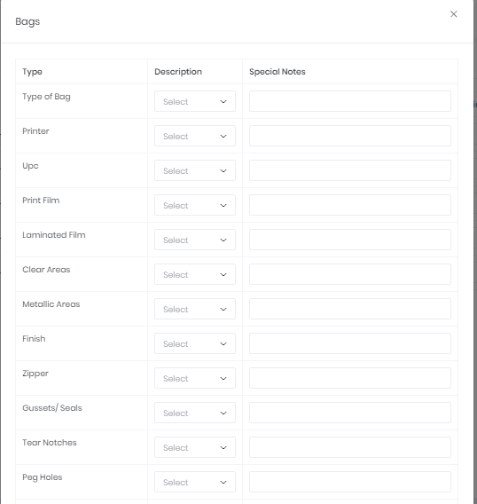

1. **Calculations:**

* Factors to consider for calculation and their locations:
* Length: Add Quote – Products input
* Width: Add Quote – Products input
* Labour Time – Product Sub-Type table
* Price – Product Material table
* Cost/minute for labour – Configuration Table (DB)

**Labour Cost = Labour Time * Cost/Minute for labour**

**Material Cost = Length * Width * Price (sum of all the sub-option’s prices for selected sub-product)**

**Unit Price = Labour Cost + Material Cost**

**Surcharge: Cost depends on type of surcharge selected from the drop-down**

**Total = Unit Price + Surcharge**

**Sub-Total = sum of all product type’s total**

**Tax = Standard: 8.25% of the sub-total**

**Discount = Depends on user’s selection**

**Grand Total = (Sub-Total + Taxes) - Discount**

### Terms & Conditions

* User should be able to view the terms and the conditions of the virtual packaging Inc.

### Save Button

* User should be able to click on Save button to save the quote for the mentioned customer and system should be able to reflect in the quotes table of that customer’s detail page.
* The system should be able to validate the fields and show following notifications:
* If all required and valid information is provided, the system should be able to show notification, ‘Quote Added’
* If some information is missing, for example name, then system should be able to show notification, ‘Please enter Name’. Syntax: ‘Please Enter ‘missing mandatory field’’ and highlight the ‘Name’ field in red.
* If invalid data entered in field, for example, characters in Phone, then system should be able to show notification, ‘Please enter valid Phone and highlight the ‘Phone’ field in red.

### Save and Approve Button

* User should be able to click on Save and Approve button to save the quotes and convert it into the job for the mentioned customer.
* System should be able to direct customer to job’s details page for that quote when user clicks on Save and Approve button.
* User should be able to fill-in information in job details page and save it into the system.
* System should be able to add this job’s information in the jobs grid of customer details page.
* System should be able to remove record of the selected quote from quotes grid and display record as job card in job’s board. (A quote once a job cannot be converted back to quote.)

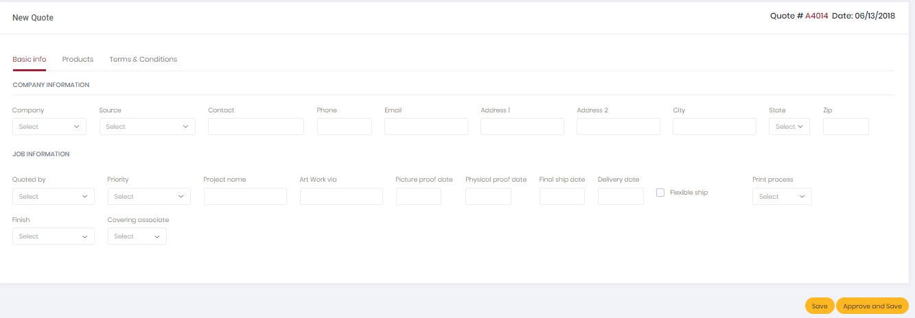

### View the list of Existing Quotes

* User should be able to click on Quotes Tab and select view quotes to open quotes list page.
* User should be able to view following columns in the quote’s grid-
* Quote Number
* Company
* Date
* Description
* Created By
* Total Amount
* Actions: Approve, Create Duplicate and Delete
* The quotes grid should be able to have pagination, giving user ability to select the number of entries to display from the drop-down.

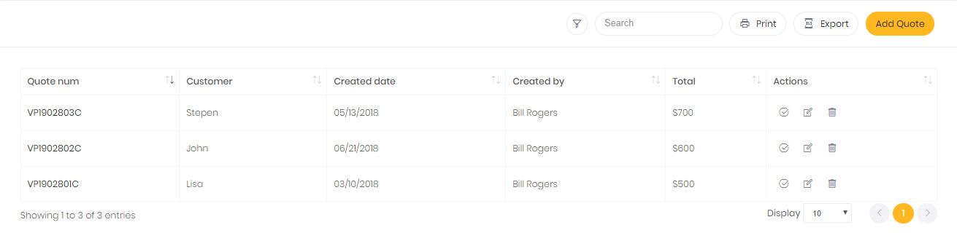

### Add Quote

**Refer 12.2 section** – Add new quote for more details

### Search Quotes

* User should be able to search the list of quotes by using quote number and Customer name
* User should be able to search the record using partial/full text.



### Filter Product

* User should be able to click on  icon to open the filter panel in the quotes tab.
* System should be able to select logged in user by default in the filter.
* User should be able to filter the quotes list by sales representative, Created date and Company name(Searchable drop-down). User should be able to multi-select the filter options with help of check-boxes.

### Actions on Grid

Refer 7.8.1 section – Quote Actions for more details

### Pagination

* User should be able to see the list of Quotes with the following paginations
* User should be able to select the number from drop-down which represents the number of records to be shown in the list, i.e. if user selects 10, the list should display 10 records, if user selects 100, the list should display 100 records from the system.



* System should be able to display the information of the range of records display out of the total.



* User should be able to navigate to available page numbers, next page or the last/first page of the list of records.



### Quotes Details Page

* User should be able to view the quote details by clicking on the quote number in quotes grid.
* User should be able to view same fields as added in Add quotes page.
* User should be able to click on  icon to go back to quotes list page.
* User should be able to view Actions drop-down in top right section of the page. Drop-down should have options - Approve, Create Duplicate and Delete

### Quotes Notes

* User should be able to write notes for selected quote by clicking on the  icon which is floating in the quote’s details page.
* When user clicks on notes icon, a panel slides open from the right. The panel has two tabs – Notes and Activities.
* User should be able to view all the notes present for the selected quotes with timestamp and who(worker) entered the notes.
* User should be able to enter the notes in the text area in the bottom section of the panel and click enter or on  icon.
* The  icon highlights in blue then there are few notes pending to be read by the user. The small bubble in red contains the number of pending notes for the selected quote. In this example, 2 notes are pending.
* Note: As soon as user reads the pending notes, this action should be recorded in Quote Notes Seen table, which records that the note was read by the logged in user.
* System should be able to add all the activities/actions happening on the selected quote in the Activities tab with timestamp.
* System should be able to record update made to customer details, quotes edited, quotes deleted, quote converted into jobs.
* System should be able to slide- close the panel to the right when user clicks anywhere outside the panel.

 

# Jobs

### View the Job’s calendar

* User should be able to view the job cards in calendar format under the jobs tab.
* User should be able to see all weekdays as columns and each column consist of the job cards of jobs assigned for the selected week day.
* System should be able to display Job status, Job Priority and Machine Type legends in the top section.

#### **Calendar header**

* User should be able to view count sections with Total Jobs, Total Designs and Total Pieces for each of the weekday in the header section.
* System auto-calculated and updates the header as and when new job card is added for that weekday.
* System should be able to sort jobs for each weekday first by priority then by spot gloss then by status.
* If job status is ‘completed’ then shift it down in list of job cards for each weekday.

#### **Job Card**

* System should be able to generate job card for each job in the system.
* System should show a specific symbol to identify the job card as Spot-gloss.
* Following are the fields displayed in the job card:
* Customer Name
* Created Date
* Job Priority
* Job status
* Printer 1
* Printer 2 (optional)
* Total no. of designs for that job (Number of designs created to make final product)
* Total no. of pieces for that job (quantity of the orders)
* Responsible person (Person responsible for this job)
* Covering associate (Person who covers originally assigned person)
* Label (visible only when shipping label is created for that job)
* System should be able to open the preview of shipping label when user clicks on label icon in job card.

1. Job Status:

|  |  |  |
| --- | --- | --- |
| Status Name | Description | Use |
| Pending Studio | Default status when a job is created | Used to identify a new job in motion for studio to receive |
| Pre-press | Job undergoing pre-press setup | Used to identify the job has been received by studio for setup |
| Pending Approval | Pre-press changes awaiting approval | Used to place the job on hold until confirmation from client/Sales |
| Pending Check | Job is currently awaiting check by sales | Used to identify that the prints have been received by production and are ready to check by sales |
| In Production | Job is currently being assembled | Used to signify that the job has been fully printed sales and is ready for assembly |
| Final Check | Job is awaiting final check by sales | Final check point before shipping is printed |
| Shipping | Job is currently being packaged for shipping | Confirmation point to ensure all shipping data is correct and labels printed |
| Completed | Job has been completed and is ready for invoicing | Job marked as complete. Will not appear in accountant queue for processing |
| Invoiced | Invoice has been completed | Total completion of job workflow. |

Status Flow:

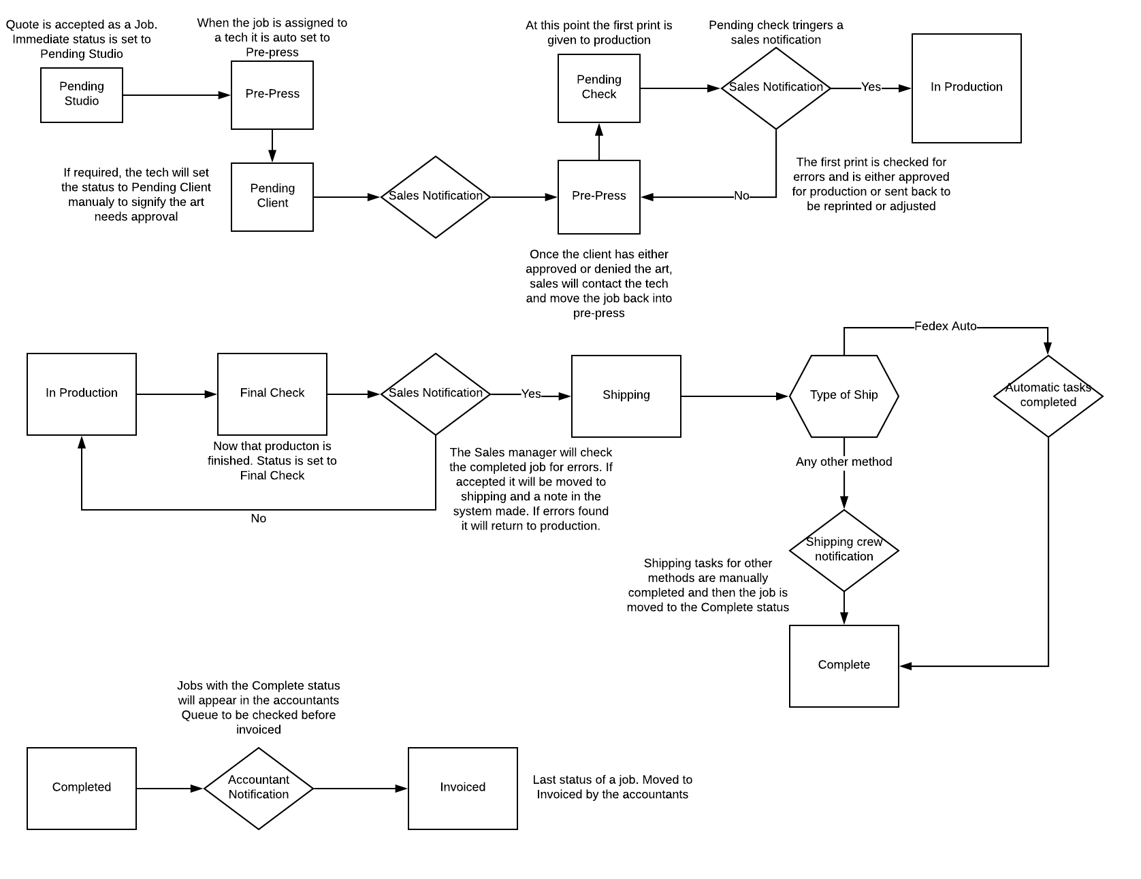

1. Job Priority:
   * 1. COURIER/PICKUP -blue
     2. UPS SATURDAY -orange
     3. COLORVU -purple
     4. STANDARD UPS -white
     5. STANDARD FEDEX -white



1. Type of Machine:
   * 1. Mimaki
     2. Screen
     3. Richo



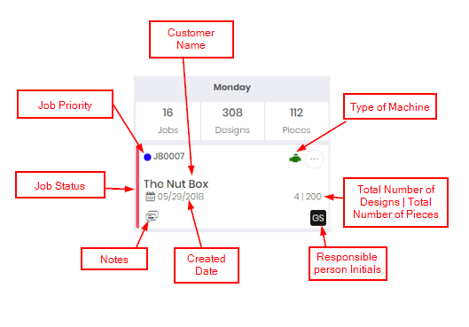

### Notes

* User should be able to write notes for selected job by clicking on the  icon which is floating in the job’s details page.
* When user clicks on notes icon, a panel slides open from the right. The panel has two tabs – Notes and Activities.
* System should be able to display job number in the top section of the notes panel.
* User should be able to view all the notes present for the selected jobs with timestamp and who(worker) entered the notes.
* User should be able to enter the notes in the text area in the bottom section of the panel and click enter or on  icon.
* The  icon highlights in blue then there are few notes pending to be read by the user. The small bubble in red contains the number of pending notes for the selected job. In this example, 2 notes are pending.
* Note: As soon as user reads the pending notes, this action should be recorded in Job Notes Screen table, which records that the note was read by the logged in user.
* System should be able to add all the activities/actions happening on the selected job in the Activities tab with timestamp.
* System should be able to record, updated made to customer details, job edited, job deleted, job’s status change.
* System should be able to slide- close the panel to the right when user clicks anywhere outside the panel.

 

### Search Jobs

* User should be able to search jobs by using job number and customer name.
* User should be able to search the record using partial/full text.



### Filter Jobs

* User should be able to click on  icon to open the filter panel in the Jobs tab.
* User should be able to filter the jobs list by status, priority, worker, machine type, spot-gloss . User should be able to multi-select the filter options with help of check-boxes.

### Actions on Grid

**Refer 7.8.3** section – Jobs Actions for more details

### Pagination

* User should be able to see previous week or next by clicking on arrows besides the date.



### Jobs Details Page

* User should be able to view the Jobs details in by clicking on the customer name in jobs card.
* User should be able to click on  icon to go back to jobs calendars page.

### Basic Information page

All the fields should be pre-populated from Quote details page. Company’s information should be read only.

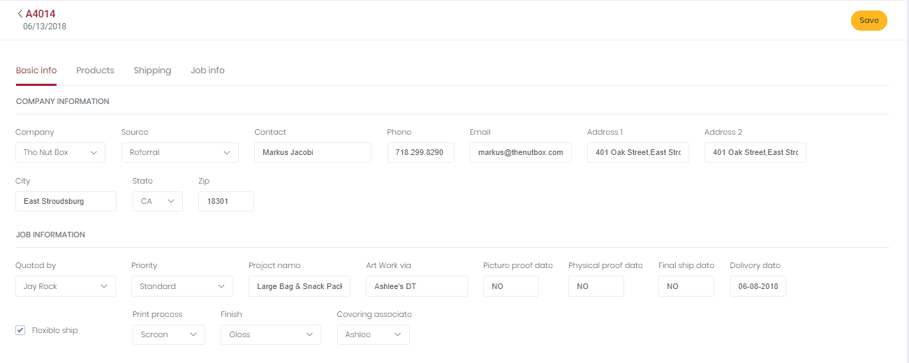

### Product Information

* All the fields should be pre-populated from Quote details page.
* User should be able to double-click on sub-product type to open material pop-up in edit mode.
* Product’s information should be read only.

### Job Information

* User should be able to display total number of designs and pieces besides the job number(title).
* User should be able to view following fields:
* Studio Associate (Drop-down)
* Latest Shipping Date (Calendar)
* Picture Proof (Check-box and Date)
* Physical Proof (Check-box and Date)
* Studio Notes (Text-area)
* Production Notes (Text-area)
* If Picture/Physical proof is checked in the Job’s detail page, then that job should be pushed to the job board on the Picture/Physical Proof date and stay there until it gets approved. Once it gets approved, that job card is removed from the job board and displayed again when the delivery is due.
* If spot gloss is selected while adding quote, then in jobs, system should be able to select Mimaki gloss as default type and give user ability to change it. But if the spot gloss is not checked, then in jobs, system should be able to select No as default type from spot gloss drop-down and give user ability to change it. **Note:** Option selected for spotgloss should be stored in database in string format.
* Display flexible ship date field in jobs info even if it is not selected while adding quote.

### Shipping Information

* User should be able to view, add, edit and delete shipping addresses for selected job of mentioned customer.
* A job should be able to have multiple addresses, and system should be able to divide the ordered quantity and ship them to different shipping addresses, using different shipping types.

**Note:** **Company name in shipping should be auto-filled based on selected job, but user should be able to edit and add some new value in company's field - in data base this record should save the company as string**

1. **Add Address:**

**Address Information:**

* User should be able to click on Add Address button to add new shipping address to the selected job. Following fields are required in add address pop-up:
* Company (Text-box) (default name as the company for which the job is created)
* Contact Name(Text-box)
* Primary Phone (Text-box) (Numeric)
* Primary Email (Text-box)
* Address1 (Text-box)
* Address1 (Text-box)
* City (Text-box)
* State (Drop-down) (Show all the states of USA)
* Zip (Text-box) (Numeric)
* Account Number (Shipping vendor account number) (Numeric) (Text-box)

**Shipping Information:**

* Number of Units (Text-box)
* Quantity (Text-box)
* Box-size (Text-box)

1. **Actions:**

* User should be able to click on Action icons - Get Quote, Edit and Delete from individual line-items in the shipping address table.

**Get Shipping Options:**

* User should be able to select get shipping option from the actions columns to get shipping quotes from shipping vendors for the selected job and shipping address.
* User should be able to view following fields in Get shipping options pop-up:

FedEx all options with Shipping Rate (text-box) besides it to enter rates (for MVP).

Courier option with Shipping Rate (text-box) besides it to enter rates (for MVP).

UPS all options with Shipping Rate (text-box) besides it to enter rates (for MVP).

* Delivery Date (Text-box)
* Signature Release (Check-box)
* Arrival Time (Time Drop-down)
* Special Instruction (Text-Area)
* User should be able to select only one sipping method at a time (only one radio button).
* System should be able to display the other fields – Delivery Date, Signature Release, Arrival Time and Special Instruction and submit button- only after user hass selected one shipping option.
* User should be able to click on submit button to trigger the action of get quotes (For MVP, clicking on submit should save rates for that specific shipping address for selected job.)
* If the quote is saved previously, then the user should be able to click on Get shipping option from action, get shipping option pop-up should be able to display all the fields with pre-populated data and system should be able to give user ability to edit and save the information.

### Save Button

* User should be able to click on Save button to save the job and system should be able to reflect in the jobs table of that customer’s detail page.
* The system should be able to validate the fields and show following notifications:
* If all required and valid information is provided, the system should be able to show notification, ‘Job Updated’
* If some information is missing, for example name, then system should be able to show notification, ‘Please enter Name’. Syntax: ‘Please Enter ‘missing mandatory field’’ and highlight the ‘Name’ field in red.
* If invalid data entered in field, for example, characters in Phone, then system should be able to show notification, ‘Please enter valid Phone and highlight the ‘Phone’ field in red.